

Project Plan - Sydney Airbnb Application

Viet My Tran Le s5235877- William Luvant s5287580 - Liangxian Zhao s2869753

Table of Contents

1.0 Introduction 2

1.1 Background 2

1.2 Scope 2

1.3 Document contents 2

2.0 Work Breakdown Structure 3

3.0 Activity Definition & Estimation 5

4.0 Gantt Chart 7

# Introduction

## Background

We are currently living in a technological world where data is an extremely crucial resource. Most of the information no matter how important they are, are contained inside databases. Moreover, we can collect information to create tables, statistics or even graphics to gain deeper knowledge and understanding regarding a situation or scenario. However, for normal human beings, it can be difficult for them to process and sort all the data. Fortunately, the rise of computers and AI help humans processing and sorting data easier. This project aims to help users group all information from the dataset given and analyse them to visualise them through the creation of a simple software tool. This software will be specifically created to process the dataset from "SYD AIRBNB Inspections".

## Scope

* The scope of this tool is to analyse and visualise the "Sydney Airbnb Inspections" dataset
* The main features are:
* Retrieve all properties listed within a user-selected period.
* Sort all properties according to the users' needs within a user-selected period.
* Retrieve all properties that contain a keyword that the user entered within a user-selected period.
* Analyse the properties’ cleanliness according to the customers comments and feedback
* Show the rating of properties based on the customers’ experience and their satisfaction toward the property.

## Document contents

This document contains the introduction of the project which includes the background of the project and its scope, a work breakdown structure, an activity definition and estimation and a Gantt chart based on the work breakdown structure defined.

# Work Breakdown Structure

Table 1 demonstrates Work Breakdown Structure to list every task that must be completed for the project. Each task in this list is allocated with a unique task ID and an estimated duration for each task. The work time is estimated to be 10 weeks and 3-5 hours per day. It is estimated that a total of around hours will be necessary to finish the building of the system and any future delivery.

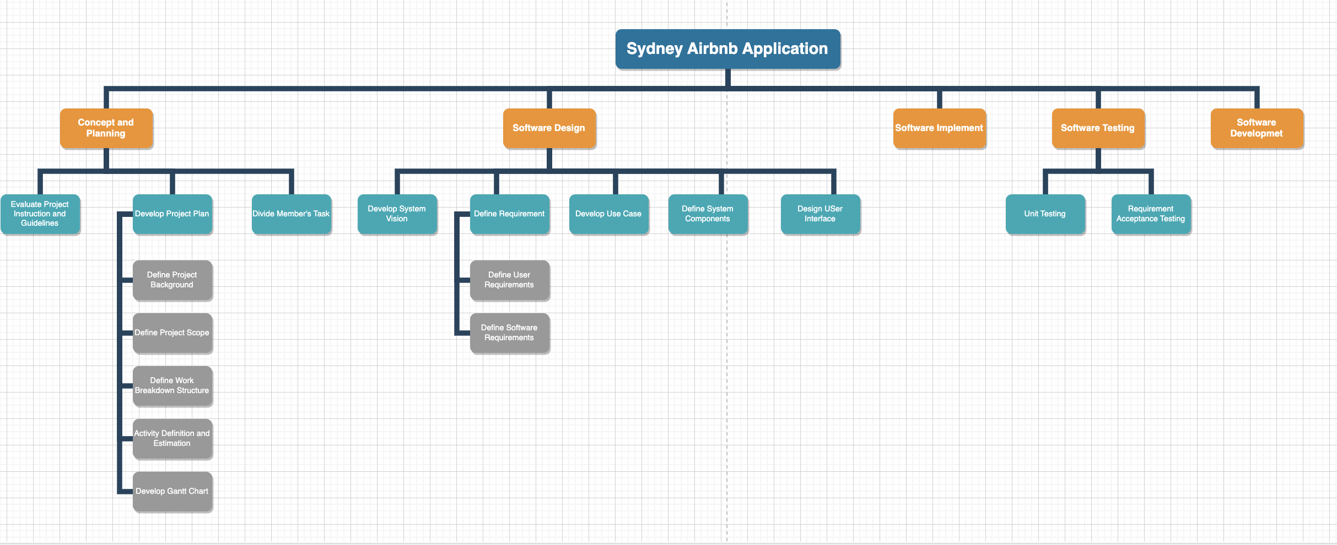

***Table 1: Work Breakdown Structure***

# Activity Definition & Estimation

|  |  |  |  |  |
| --- | --- | --- | --- | --- |
| **Activities** | **Definition** | | **Estimation** | |
| 1.0 Concept and Planning | This activity is about getting to know the concept of the project and plan it with the tools required to complete the project | | 2days | |
| 1.1 Evaluate Project Instruction and Guidelines | Understand client’s requirement regarding on:     * Distribution of violations over the different suburbs inspection details * Key words enter searching * Inspection details * Customer review | | 3days | |
| 1.2 Develop Project Plan | The designed project plan specific satisfy users’ expectation by restaurant rating | | 2days | |
| 1.2.1 Define Project Background | Sydney Airbnb inspection system is a program demonstrate minimum function related to airbnb analysis | | 2days | |
| 1.2.2 Define Project Scope | In scope:   * Data visualization by different format * Easy to illustrate restaurant inspection data by entering key words * Processing data by certain time of period * Examine living condition over time and across different neighbourhoods. * Summarize the number of infractions committed in each suburb within the time period specified by the user | | 4days | |
| 1.2.3 Define Work Breakdown Structure | This software project result-oriented work breakdown structure focus on project design, project management, analysis, designing, developing, and testing stages. | | 3days | |
| 1.2.4 Activity Definition and Estimation | Defining the activities in the work breakdown structure and estimating duration needed to complete each activity | | 3days | |
| 1.2.5 Develop Gantt Chart | Creating a Gantt chart based on the work break down structure and activity definition and estimation | | 5days | |
| 1.3 Divide Member Tasks | Divide tasks among team members | | 1day | |
| 2. Software Design | The components of software design are listed:     * User opens app * User chooses function * (If needed) User enters time period/keyword/etc * App displays analyzation and visualization of “Sydney Airbnb Inspection” dataset with chosen function and customization by user * User chooses to close app or to do another session | | 3days | |
| 2.1 Develop System Vision | Its goal is to help the client in decision making of a development project by giving them an understanding of the problem and the proposed solution. | | 2days | |
| 2.2 Define Requirements | Software requirements a document that outlines the functions that the programme will be required to fulfil and how it will carry out those functions. Additionally, it outlines the functionality that the product satisfies the stakeholders. | | 2days | |
| 2.2.1 Define User Requirements | Is a standard tool lists function and features that meet requirement of end-user | | 2days | |
| 2.2.2 Define Software Requirements | This part is to make sure that every member of the project team understands the project and clearly know what the software needs, its purpose and functionalities. | | 2days | |
| 2.3 Develop Use Cases | A use case is a scenario that illustrates how a user might use a certain feature of a product or service. The use case might define the optimal and worst-case possibilities, as well as any important outliers. With the use case model tool, a use case may be written down or turned into a graphic. | | 5days | |
| 2.4 Define System Components | A system component is a procedure, application, or utility on a computer, as well as any other component of the operating system of a computer, that assists in the management of various sections of the computer. | | 3days | |
| 2.5 Design User Interface | Concepts from information architecture, graphic design, and interaction design are brought together under the UI umbrella. Interface provides features that are simple to access, understand, and utilise to assist those tasks. | | 2days | |
| 3.0 Software Implementation | Based on the scope of the firm and the nature of the new tool or programme, introducing it might be a challenging endeavour. It is often used to describe the steps necessary to incorporate a new software programme into an existing company system. | | 10days | |
| 4.0 Software Testing | Testing implemented software | | 7days | |
| 4.1 Unit Testing | Test each unit of the software | | 7days | |
| 4.2 Requirement Acceptance Testing | The major goal of this test is to determine if the system is ready to be released to end users by determining whether it complies with the business requirements. | | 4days | |
| 5.0 Software Deployment | The components of designing, documenting, developing, and testing a software product, as well as continuing maintenance on the software, is referred to as software development. | | 7days | |
|  |  |  | |  | |

***Table 2 Activities definition& Estimate***

# Gantt Chart

Figure 1 illustrate the estimated work breakdown structure as visualized Gantt chart. The task duration and work date are designed for project schedule arrangement. The Gantt chart document can be attached on Gitlog.

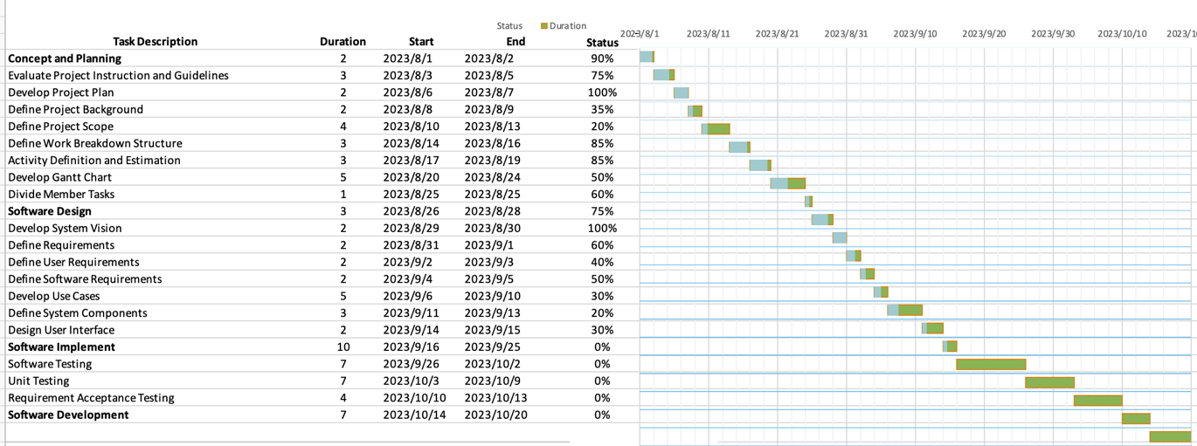

***Figure 1. Gantt chart***